14년 3월 1일 10:30 🡪 10/22 10:00

**Part 1**

Q1. Thank you to everyone who attended the computing for success conference. We are deeply grateful to Dr. Lu who organized the conferences and set up lectures. Finally, I want to thank the dedicated, hard working, and efficient staff who made our event reality.  I hope you see you at the next year’s conference.

Q2. Welcome everyone to the Sweets and Treats candy factory. We are excited to show you around our factory which is celebrating its fiftieth anniversary. You will watch a video about our history, production line and some samples of our candy. After that you will be able to purchase your favorites at our gift shop. We have limited time, so let’s get started.

**Part 2**

**< 공원에서 찍힌 사진 >**

왼쪽에는 멋진 유럽스타일의 건물들이 있었고, 그 앞 운하에는 배가 떠있었음.

앞쪽에는 흰머리를 한 남자가 배낭을 매고 오렌지색 자전거를 타고 있고,

앞쪽에 자전거 한대는 묶여 있었으며, 남자 셋이 난간에 기대어 서있었음.

중간에는 잎이 풍성한 나무들이 보였음.

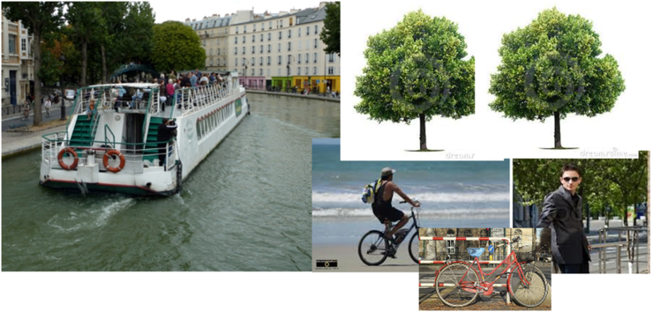

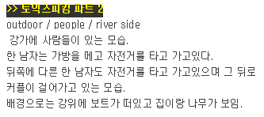 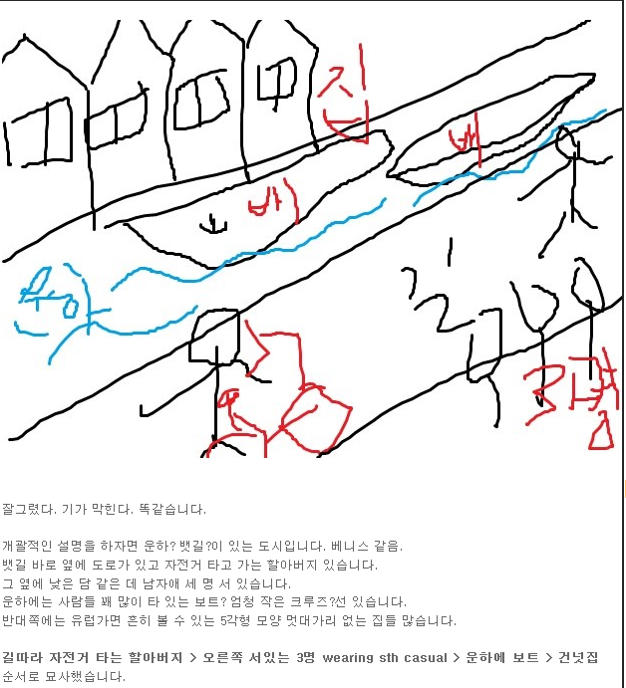

**Part 3**

Imagine that a technology magazine is doing research in your area. You have agreed to participate in a telephone interview about **video conferences in which people use computers to see and have conversation with co-workers or classmates.**

**Q4.When was the last time you participated in a video conference to communicate with a co-worker or classmate?**

I have never participated in a videoconference to communicate with a co-worker or classmate. But I often keep intouch with people by emailing or texting.

**Q5. In the next few years, do you think you will participate in more video conferences than you do now? Why or why not?**

Yes. I do. In the next few years, I think I will participate in more video conferences than I do now. The internet has greatly improved. With help of the internet, people will have more chances to participate in video conferences.

**Q6. If you had a meeting, would you prefer to have a video conference or to meet inperson? Why?**

If I had a meeting, I would prefer to have a video conference. By having a video conference, I can save time and cost onhave a meeting in person. Also, nowadays, the internet has greatly improved. With help of the internet, I can keep in touch with people half away from the world. So, it is more convenient to have a video conference.

**Part 4**

|  |  |
| --- | --- |
| **Professor Tim Kirby**  Agenda for Tuesday April 16th | |
| 8:30-9:00 | Review notes: General medical lecture |
| 9:00-11:00 | Lecture: General medicines |
| 11:30-noon | Interview with Sara Parks (surgical intern position) |
| Noon-1:00 | Lunch: Dr. Singh |
| 1:00-1:15 | Call David Ross: Confirm details (time, room) for conference presentation |
| 1:30-3:30 | Clients hours |
| 3:30-5:00 | Revise conference presentation notes |

**Narration:** Hi, this is Dr. Kirby. I’d like to prepare for tomorrow, but I don’t have my calendar with me. I need you to tell me a few things about what’s on my schedule.

Q7. What do I have scheduled before 9 o’clock?

Q8. I’d like to have lunch with Dr. Perris. That won’t be a problem, will it?

Q9. I know I set a time in the afternoon to prepare conference presentation. Can you tell me all the details about what I am doing tomorrow to prepare for the conference?

**- 7번 8시 반부터 뭐뭐ㅏ시기가 있다.**

**- 8번 안돼 다른 스케줄 있어.**

**- 9번 3개 있었어요. According to the inf I have, there`re 3 sessions. 이후 순서대로 읽음.**

- 7번 8시 반부터 뭐뭐ㅏ시기가 있다.

- 8번 안돼 다른 스케줄 있어.

- 9번 3개 있었어요. According to the inf I have, there`re 3 sessions. 이후 순서대로 읽음.

**Part 5**

Q10. Hi, it’s Albert Geiger, the owner of the used book store. Since you are the store manager, I am going to ask you to solve a problem about how to help our customers find books at our store. We have a wide variety books on all kinds of topics and have a clear system for organizing them. It’s just that customers don’t know where to find what they are looking for. Sometimes they think that we don’t have the books they want, and they go somewhere else to buy them. We are starting to lose our business, so I want to make it easier for customers locate specific books in our store. What can we do to help customers find what they are looking for? Please call me back with your ideas. Again, this is Albert. Thanks.



검색 시스템을 만들어라/직원 더 고용해라 이런 쉬운게 있었는데도 불구하고

후천적 언어장애인 저는 빠른 생각을 해내지 못했습니다. 그래서 해결책이랍시고 내놓은게 가게에다가 안내사항이나 목차 같은 거 만들어서 사람들이 쉽게 찾아갈 수 있게 하라. 이런 식으로 했습니다.

Hi, Swami. This is Sarah An returning your call. I got your message saying that you are worried that you are loosing customers because people have a hard time finding our products at our store, right? I am glad that I can help you so don't worry about anything.

Here are my suggestions for you. We can hire more staff so that they can help people to find items. And then, we need to place and post signs describing exactly where things are (located). This will help people find our items easily. Lastly, we can handout brochures of our products or pamphlets showing where they are (stocked) so that people can easily check out and find items.

I hope this will work out well and feel free to call me if you have any further questions. Goodbye.

인사: Hello. This is ~. I am the manager.

배경: I got your message saying our customers are complaining that they cannot find tools they are looking for.

문제점:However, our employees cannot help customers.

요구사항: So, you want me to check on this matter.

연결문장: First of all, I am sorry to hear that. After checking into this situation, I found out some possibilities. Here I will come up with these solutions.

해결책: First of all, I will train our employees to make them familiar with our items. Also, why don’t we set up computers to assist our customers? **they can easily find what they are looking for.** I am sure all of our customers will have no problem finding what they are looking for. These are my suggestions.

마무리: If you have any further questions, please call me back. Thank you.

**Part 6**

Do you agree or disagree with the following statement?

*“The media should not be allowed to report on private lives on public figures like politicians and celebrities”.*

Give specific reasons and examples to support your opinion.

Do you agree or disagree with the following statement?

***“The media should not be allowed to report on private lives on public figures like politicians and celebrities”.***

Give specific reasons and examples to support your opinion.

주장: I disagree with the following statement that the media should not be allowed to report on private lives on public figures like politicians and celebrities.

연결문장: I have several reasons to support my opinion.

근거1 : First of all, I think that public figures should accept that the public pay close attention to their private lives.Celebrities live on the public’s attention and love. I mean, accepting the public’s attention is one of their duties as public figures. The public have a right to know their lives.

근거2: Also, they can have a great influence on our society and the public especially for children and teenagers. They are too young to control themselves. They cannot figure out what is wrong or right and what is good or bad. It is natural for them to pay attention to celebrities’ everything including the celebrities’ private lives.

결론: That’s why I don’t think that the media should not be allowed to report on private lives on public figures like politicians and celebrities.

14/4/6 11:30 🡪 10/22 12:00

**Part 1**

Q1.Hello, you’ve reached Farley Real Estate Company, your local real estate experts. Unfortunately, no one is available to answer your call right now. Please leave a message including your contact information. One of our agent swill call you back during business hours. Farley Real Estate, we are always seager to your buying, selling, and renting needs.

Q2.Welcome to the Flower City Arts Festival, our annual celebration of the talented artists in our area.  We will beenjoying a series of wonderful concerts, dramas, and dance performances shortly.  But before that, please join me in welcoming our mayor, who will give opening remarks.

**Part 2**

**< 동남아나 아시아 국가의 교차로에서 찍힌 사진 >**

구도는 아래 사진과 매우 흡사하나 사람들이 이렇게 많지는 않았음.

오히려 두 번째 사진처럼 몇 명이 건너고 있었지만,멀리서 찍힌 사진이라 옷이나 표정 등은 전혀 보이지 않았음.

가게들이 즐비해 있고 왼쪽에 차들이 멈춰있었음.

특이한 것은 횡단보도나 차선이 하나도 보이지 않았습니다.

사진의 위쪽에는 다리 같은 것이 있었고 몇 명이 지나가고 있었습니다.

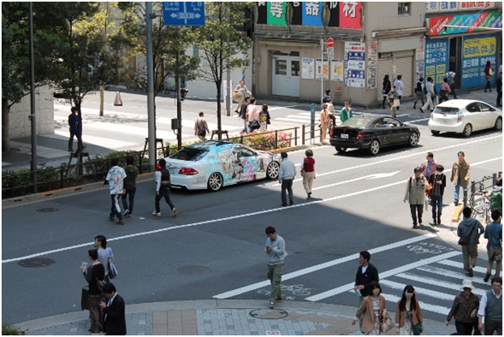

[**팟2 모법답안 확인**](http://cafe.naver.com/toeicspeakinginwm/787)

 Intersection : 교차로

Crosswalk: 횡단 보도

Cross the street : 길을 건너다.

Signboard: 간판

Banner : 현수막

도입:I think this picture was taken at the intersection.

주요대상:Inthis picture, there are a lot of people crossing the street. One of them isa guy looking at something in his hands. It seems like he is using his cellphone. He is wearing a grey shirt and cargo pants. Also, some cares arestopped on the road. It looks like the cars are waiting for the greenlight.

배경:In the background of the picture, there are some stores in the buildings.Some signboards are hanging from the building. I can see some trees with greenleaves.

마무리:Overall, this street looks crowded and busy.

**Part 3**

Imagine that a technology magazine is doing research in your area.  You have agreed to participate in an interview about **video chat in which people use computers to see and have conversations with friends.**

Q4.When would you be most likely to use video chat to talk to friends?



Q5.Suppose someone wanted to schedule to have a video chat with you, how far inadvance, would you like to be contacted about it, and why?

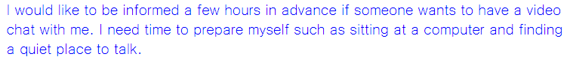

Q6.Which is more convenient, talking on the phone with your friends or having avideo chat with them, why?

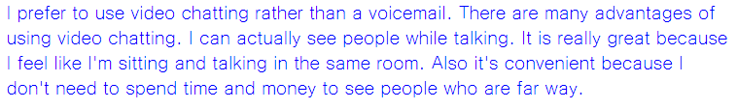

**Part 4**

|  |  |
| --- | --- |
| International marketing conference  Albright Conference Center- Cape town, South Africa | |
| **Month, 16 March** | |
| 9:30- 11:00 | How the internet is changing markets around the world |
| 11:00-12:30 | Global consumers- developing trends |
| 1:30-2:30 | Recognizing good advertisements |
| 2:30-4:00 | Going Green-New environmental standards |
| **Tuesday, 17 March** | |
| 9:30 -11:00 | Marketing team-New audiences |
| 11:00-12:30 | Researching new audiences for existing products |
| 1:30-2:30 | Interpreting Consumer data |
| 2:30-4:00 | Top 5 mistakes in advertisement |

**Narration:** Hello, I saw an advertisement on the internet about marketing conference that you are organizing. I was hoping I can get more information about it.

Q7.Where is the conference being held?



Q8. The conference will be only one day event, right?

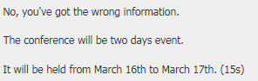

Q9. I am most interested in marketing. Could you please tell me the details of the sessions that are specifically about advertising?

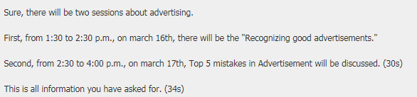

**Part 5**

Q10. Hi, this is Matt Gorman, the apartment building manager. Since you are my assistant, I need you to come up with a plan to keep track of our cleaning supplies, you know, the mops, brooms, sponges, and other items. As you know, there is a storage closet on the first floor of the building where we keep our cleaning supplies for all residents to use. People often borrow these items and don’t return them. This has been going on for along time, and we need to spend a lot of money to replacing them. We want to continue making these supplies available to our residents. So, I need you to come up with a solution to create a system to keep track of the cleaningsupplies in the closet. Please call me back with a plan to monitor these cleaning supplies in the storage closet. Again, it’s Matt.

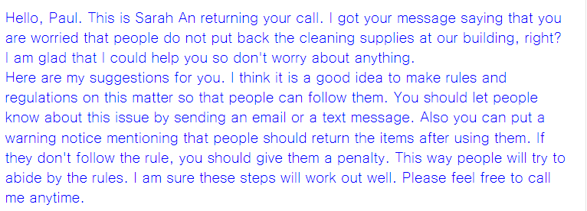

**Part 6**

Q11. Do you agree or disagree with the following statement: “nowadays, people care more about the social lives of movie stars than acting skills of movie stars.” Give specific reasons or examples to support your opinion.

